Practical no.3

Title-SQL operator and function
1)write SQL queries using arithmetic,comparison,logical,and special operators.

Example:
- Arithmatic operator : SELECT inst_name, fees, fees + 1000 AS new_fees
FROM Institute;
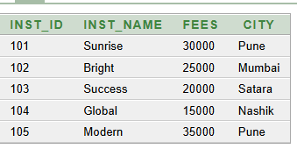

- Comparison operator: SELECT inst_name, fees, fees - 1000 AS less_fees
FROM Institute;
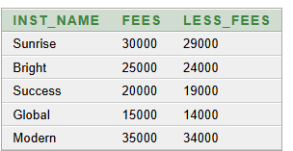

- Logical operator: SELECT inst_name, fees, fees * 2 AS double_fees
FROM Institute;
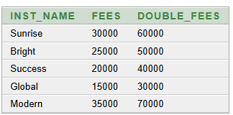

- Special oprator: SELECT inst_name, fees, fees / 2 AS half_fees
FROM Institute;
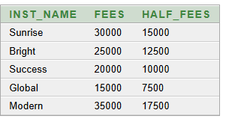

2)demonstrate string,numeric,date-time,and aggregate functions

- String:
- SELECT UPPER(inst_name) AS upper_name
FROM Institute;

FROM Institute;
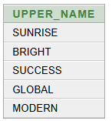

- SELECT LOWER(inst_name) AS lower_name
FROM Institute;
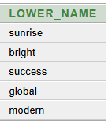

- SELECT SUBSTR(inst_name, 1, 3) AS short_name
FROM Institute;
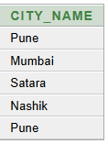

4. SELECT inst_name, LENGTH(inst_name) AS name_length
FROM Institute;
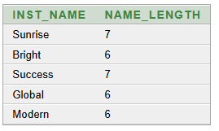

5. SELECT SUBSTR(inst_name, 1, 3) AS short_name
FROM Institute;
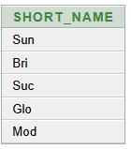

- Numeric:
1. SELECT ROUND(125.678, 2) AS result
FROM DUAL;
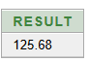

2. SELECT ABS(-500) AS result
FROM DUAL;
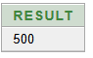

3. SELECT CEIL(25.3) AS result
FROM DUAL;
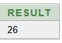

4. SELECT FLOOR(25.8) AS result
FROM DUAL;
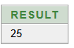

5. SELECT MOD(10, 3) AS remainder
FROM DUAL;
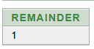

- Date-time:
1.SELECT SYSDATE
FROM DUAL;
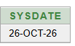

2. SELECT ADD_MONTHS(DATE '2024-12-01', 2) AS NEW_DATE
FROM DUAL;
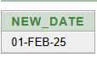
3. SELECT MONTHS_BETWEEN(DATE '2024-12-01',DATE '2024-01-01'
) AS TOTAL_MONTHS
FROM DUAL;
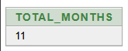

4. SELECT TO_CHAR(
DATE '2024-12-01',
'DD-MM-YYYY'
) AS FORMATTED_DATE
FROM DUAL;

